**CENWP-OD-B 06 September 2023**

**MEMORANDUM FOR THE RECORD**

**SUBJECT: 23BON087 MFR AFF Valve 15 Salmonid Mortalities**

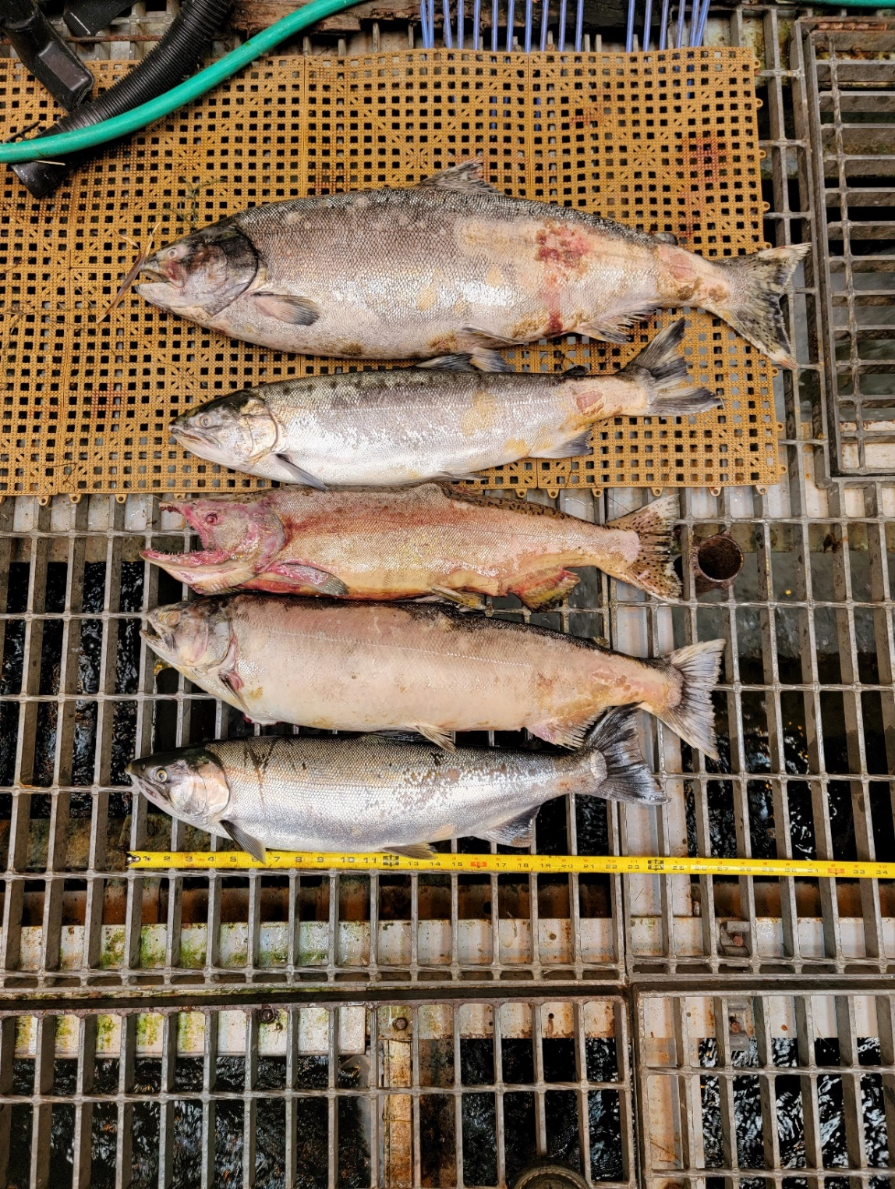In the morning of 06 September, Columbia River Inter-Tribal Fish Commission (CRITFC) Biologists notified Bonneville Project Biologists of five salmonid mortalities found on the Valve 15 trash rack in the Adult Fish Facility (AFF). The fish were all scanned for PIT tags, inspected, and returned to the river.

#1

1. Species – Chinook Salmon (*Oncorhynchus tshawytscha)*
2. Origin – Unknown
3. Length – 83.8 cm
4. Marks and tags – No PIT tag
5. Marks and Injuries found on carcass – General decay.
6. Cause and Time of Death – Unknown
7. Future and Preventative Measures – None

#2

1. Species – Coho Salmon (*Oncorhynchus kisutch)*
2. Origin – Unknown
3. Length – 67.3 cm
4. Marks and tags – No PIT tag
5. Marks and Injuries found on carcass – General decay.
6. Cause and Time of Death – Unknown
7. Future and Preventative Measures – None

#3

1. Species – Chinook Salmon (*Oncorhynchus tshawytscha)*
2. Origin – Unknown
3. Length – 61.7 cm
4. Marks and tags – Adipose clip, no PIT tag
5. Marks and Injuries found on carcass – General decay, hemorrhaging.
6. Cause and Time of Death – Unknown
7. Future and Preventative Measures – None

#4

1. Species – Salmonid (*Oncorhynchus spp.)*
2. Origin – Unknown
3. Length – 70.1 cm
4. Marks and tags – No PIT tag
5. Marks and Injuries found on carcass – General decay, descaling, discoloration, hemorrhaging.
6. Cause and Time of Death – Unknown
7. Future and Preventative Measures – None

#5

1. Species – Coho Salmon (*Oncorhynchus kisutch)*
2. Origin – Unknown
3. Length – 63.5 cm
4. Marks and tags – No PIT tag
5. Marks and Injuries found on carcass – General decay.
6. Cause and Time of Death – Unknown
7. Future and Preventative Measures – None

Sincerely,

Bonneville Project Fisheries